Technology Department ReadyDesk Software

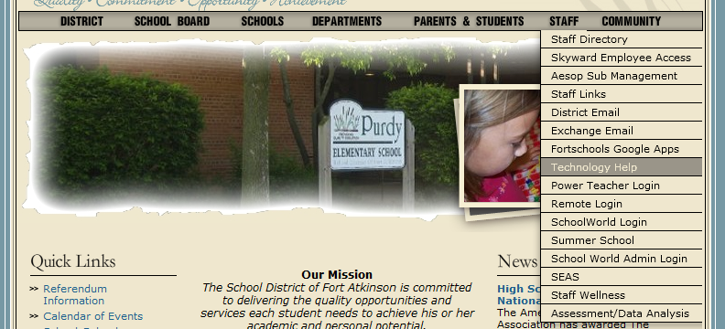**OPENING READYDESK**

1. From District Home Page, highlight the “Staff” Tab, and select “Technology Help”
2. From the next Screen, Select “Please click here to open the technology department’s help desk website”
   1. You will also be able to get to this website next year by clicking on a “Technology Help” icon on your desktop.
3. Enter Customer ID and password for ReadyDesk. For more information about what your username and password are, please refer to text box below.

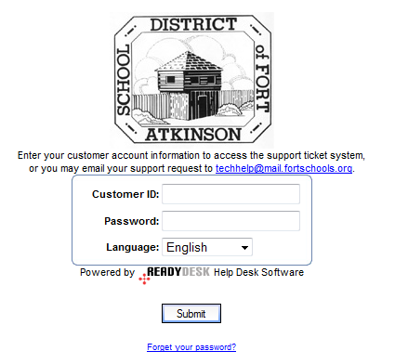

Customer ID: Last Name + First Name First Initial

(ex. fritschc)

Default Password: Same as Username

(ex. fritschc)

If you have any issues with your username and password, please do one of the following.

1. Email techhelp@mail.fortschools.org
2. Call 920-563-7813
3. Click “Launch Gradebook”

**CREATING A NEW TICKET**

A work ticket is created whenever you have an issue that you would like fixed by a computer technician. This will take the place of all emails and phone calls when making the Technology Department aware of an issue.

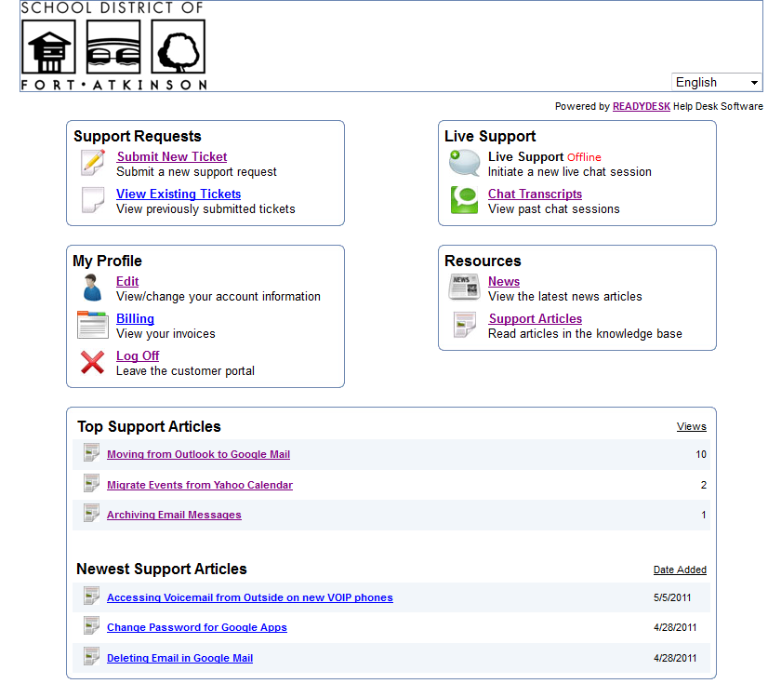

1. Click on “Submit New Ticket”
2. Fill in the following information. The more information that you provide in the Summary section, the better your service will be from the Technology Department. This form allows you to upload documents. This will help if you have created a screen shot of an error.
3. 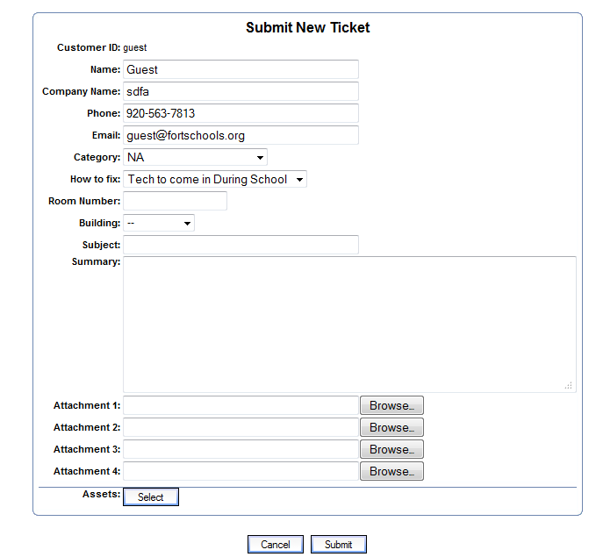After you have finished inputting your information, click “Submit”.

**VIEW EXISTING TICKETS**

Existing Tickets will show you information about any Open or Closed Tickets that you have created in the past. Each ticket will include a history of what was done by the Technology Department to fix your issues.

1. Click on “View Existing Tickets”
2. Click on the “Subject” of a ticket to open it.

**UPDATE EXISTING TICKETS**

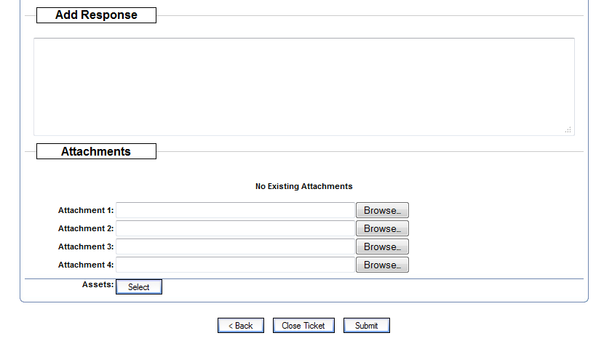When you click on an existing Ticket, you have an option to update your ticket. This can include you typing in more information about your issue, or even closing your work ticket if the issue has resolved itself.

**CHANGING YOUR PASSWORD**

Because the default password is not very secure, we ask that you change your password. We do not use the “Billing” link under “My Profile”. But, you can log off by clicking the “Log Off” link.



1. Under “My Profile”, click on “Edit”
2. Update your information.
3. Click Submit.

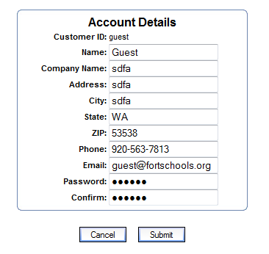

**RECEIVING IMMEDIATE HELP**

With this new helpdesk software, the Technology Department will now have access to share your screen with you immediately. The Live Support Chat and Remote Desktop will only be available if there is a Technician also available in the department.

1. Under “Live Support”, Click The Live Support Link. You will be able to click on this only if we have a technician signed into the Live Support in the Tech Department.

Times that Live Support will be available will be determined this summer.

The times will then be posted inside of Ready Desk, and sent out in an email.

We are hoping to have Live Support available at least every morning from 7:45am -9:00am.

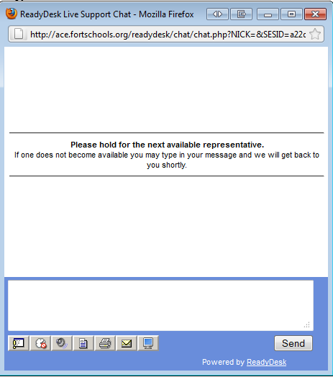

To Share Screens with a Tech.

**VIEWING NEWS FROM THE TECH DEPARTMENT**

The Technology Department will post any news or updates that will be going on in the future to this page. This may include when there will be outages to certain services, or just information about what the Technology Department is up to.

**VIEWING SUPPORT ARTICLES FROM THE TECH DEPARTMENT**

The Technology Department will post helpful hints and tips in the Support Article section. This should be the first place that you look for help for your technology issues. This will allow you to search for keywords of what you are looking for. The bottom of your Ready Desk screen will show you “newest” and “most used” Support Articles. We will be including a lot of Support Articles that will help you with your transition into using Google Apps.

